Mentor Name: Mr.R.Kennady

Email Id: [kennady.r@ritchennai.edu.in](mailto:kennady.r@ritchennai.edu.in)

**Department of Artificial Intelligence and Data Science**

Rajalakshmi Institute of Technology

**ABSTRACT:**

This study delves into the analysis of data to uncover patterns and relationships between various attributes related to vehicle warnings and their corresponding time and speed. The findings reveal that the most prevalent warning, constituting approximately 57% of the dataset, is associated with heavy monitoring, with a total of 12,328 instances. Following closely is the lane departure warning, accounting for roughly 30% of the dataset, amounting 6,431 instances. This is type of warning is typically observed in highway scenarios, particularly in the central areas like Southern Grand Trunk Road and Anna Salai. The study’s focal point for traffic initiation is the Vandalur Zoological Park Area.

Name: Bharavi S

Email Id: [bharavi.s.2021.ad@ritchennai.edu.in](mailto:bharavi.s.2021.ad@ritchennai.edu.in)

**Department of Artificial Intelligence and Data Science**

Rajalakshmi Institute of Technology

Name: Bhuvanshankar K

Email Id: [bhuvanshankar.k.2021@ritchennai.edu.in](mailto:bhuvanshankar.k.2021@ritchennai.edu.in)

**Department of Artificial Intelligence and Data Science**

Rajalakshmi Institute of Technology

**Date: 9/9/2023**

Name: Akilan K

Email Id: [akilan.k.2021.ad@ritchennai.edu.in](mailto:akilan.k.2021.ad@ritchennai.edu.in)

**Department of Artificial Intelligence and Data Science**

Rajalakshmi Institute of Technology

**Report on the Intel Grand Challenge**

* The dataset provided for analysis contains road safety alerts collected from on-road events Vehicle-to-everything technology(V2X) that refers to the sensors, cameras and wireless connectivity that allow vehicles to share real-time information with their drivers, other vehicles, pedestrians and roadway infrastructure like traffic lights. These alerts are essential in helping prevent collisions between vehicles.
* One of the main challenges we encountered during this analysis was identifying patterns and high-traffic alert areas that require special attention due to safety concerns.
* To make the data suitable for analysis, we performed data cleansing and transformation using Microsoft Excel. This step was crucial in ensuring the accuracy and consistency of the dataset.
* Additionally, we utilized Tableau software for Data Visualization. This allowed us to gain insights into the data's distribution and variations. We employed various types of plots such as bubble plots, scatter plots, and heatmaps to visualize and analyse the data effectively.
* For geographical analysis and to gain a deeper understanding of the alert areas in relation to latitude and longitude, we turned to Kepler.gl. This tool helped us visualize and analyse the data in a spatial context, providing valuable insights into the geographic distribution of safety alerts.

**INTRODUCTION:**

**DATA SOURCE:**

**ANALYSIS**

In the dataset, we have

i) FCW-Forward Collision Warning

ii) PCW-Pedestrian Collision Warning

iii) LDW- Lane Departure Warning

iv) HMW- Headway Monitoring Warning

we also have column of the data of the event, latitude, and longitude of the event that occurred.

With that data, we can able to derive the insight of the traffic alert area

**On the data analysis of the dataset, we have second insight with total count of 21325**

|  |  |
| --- | --- |
| **maximum Speed** | **65** |
| **Minimum Speed** | **0** |
| **Average Speed** | **38.34966216** |
| **Count** | **21325** |
|  |  |

**Forward Collision Warning**

In the where vehicle type 5339, holds 204 count and vehicle 805 hold 158 count and 2846 vehicle with count of 2846 with the total of 509 count of vehicle. Which contain maximum speed of 63 and average speed of 38 km/hr. and holds 270 of the total count

|  |  |
| --- | --- |
| **maximum Speed** | **64** |
| **Minimum Speed** | **0** |
| **Average Speed** | **35.3166** |
| **Count** | **12328** |
|  |  |

**HEADWAY MONITORING**

|  |  |
| --- | --- |
| **maximum Speed** | **63** |
| **Minimum Speed** | **0** |
| **Average Speed** | **36.34966216** |
| **Count** | **590** |
|  |  |

**PEAK ROUTE: VCH 805 / TIME (7. AM) ROUTE - VANDALOOR TO GUINDY) COUNT - 48**

In headway monitoring, where vehicle type 805 vehicle holds 6875 count; major in it and next to the vehicle 5339 holds 5842 and vehicle 2846 hold 5886 count. Which contain maximum speed of 64 km/hr and average of 35 km/hr and 57% of the total count

**PEAK ROUTE: Crescent college Vandalur diverges into the count southern trunk and another one to annasalai -CEG-Chennai.**

On the lane monitoring, where vehicle 806 holds count of 247 count Arnd vehicle type 805 holds 2052 count and total of 6431 count. The maximum speed 65 km/hr and the average speed of 50.9 km/hr and holds 30% of the total count

**LANE MONITORING**

|  |  |
| --- | --- |
| **maximum Speed** | **65** |
| **Minimum Speed** | **0** |
| **Average Speed** | **50.92349557** |
| **Count** | **6431** |
|  |  |

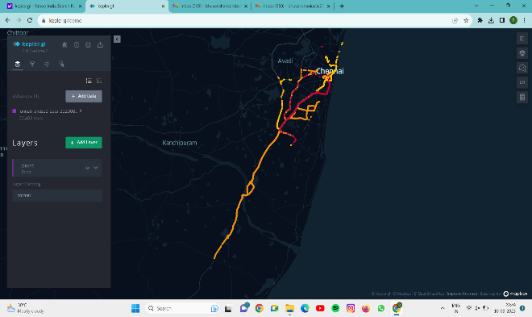

a)Visualization of Data given

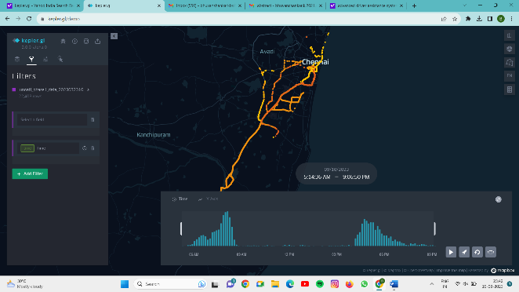

b) Visualization of data with Time

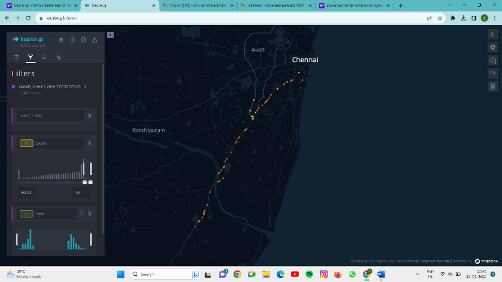

c) Visualization of data with Speed range between 60.02 – 65m/s